

**Semester 2 Examination, 2019**

**Question/Answer Booklet**

**COMPUTER SCIENCE ATAR Year 11**

**Units 1 & 2**

**Answer guide for Semester 2 Exam**

Student Name:

Student Number:

Teacher’s Name: Ms Radzi

**Time allowed for this paper**

Reading time before commencing work: 10 minutes

Working time for paper: 3 hours

**Materials required/recommended for this paper**

***To be provided by the supervisor***

This Question/Answer Booklet

***To be provided by the candidate***

Standard items: pens, pencils, eraser, correction fluid/tape, ruler, highlighters

Special items: non-programmable calculators satisfying the conditions set out by the Curriculum Council for this course

**Important note to candidates**

No other items may be taken into the examination room. It is **your** responsibility to ensure that you do not have any unauthorised notes or other items of a non-personal nature in the examination room. If you have any unauthorised material with you, hand it to the supervisor **before** reading any further.

**Structure of this paper**

|  |  |  |  |  |  |
| --- | --- | --- | --- | --- | --- |
| Section | Number of questions available | Number of questions to be answered | Suggested working time (minutes) | Marks available | Percentage of exam |
| Section One:  Multiple-choice | 20 | 20 | 20 | 20 | 12 |
| Section Two:  Short Answer | 20 | 20 | 80 | 70 | 44 |
| Section Three:  Extended answer | 8 | 8 | 80 | 70 | 44 |
|  |  |  | **Total** | 160 | 100 |

**Instructions to the Candidate**

1. Answer the questions according to the following instructions.

Section One: Answer all questions on the Question/Answer Booklet. For each question, circle the letter to indicate your answer (either a, b, c or d). If you make a mistake, place a cross through that letter, do not erase or use correction fluid, and circle your new answer. No marks will be given if more than one answer is completed for any question.

Section Two and Three: Write your answers in this Question/Answer Booklet.

1. When calculating numerical answers, show your working or reasoning clearly unless instructed otherwise.
2. You must be careful to confine your responses to the specific questions asked and to follow any instructions that are specific to a particular question.

‘

**This page has been intentionally left blank.**

**SECTION ONE - MULTIPLE CHOICE 20 MARKS**

**Circle the letter of the best answer.**

1. **(1 mark)**

110100112 is an example of what type of number?

* 1. Decimal number.
  2. Octal number.
  3. **Binary number.**
  4. Machine number.

1. **(1 mark)**

Which of the following is a hexadecimal number?

* 1. AS39.
  2. 1M4B.
  3. 90HJ.
  4. **3B9E.**

1. **(1 mark)**

Software licensing that allows the user to modify the code is known as

* 1. Commercial.
  2. HTML.
  3. **Open source**
  4. Shareware.

1. **(1 mark)**

Which of the following lists the order of program language evolution from lowest to highest?

* 1. Assembler, non-procedural, procedural, object-oriented, machine code.
  2. Object-oriented, non-procedural, procedural, machine code, assembler.
  3. Machine code, assembler, object-oriented, non-procedural, procedural.
  4. **Machine code, assembler, procedural, non-procedural, object-oriented.**

1. **(1 mark)**

The code below is an example of what programming language?

MOV EAX, 1

SHL EAX, 5

MOV ECX, 17

SUB EAX, ECX

* 1. **Assembler.**
  2. Non-procedural.
  3. Object oriented.
  4. Procedural.

1. **(1 mark)**

The following IF statement needs to be tested in a desk check.

If Number > 12 and Number < 18 then

Output (Number)

End IF

The best set of test data to use for Number, so as to check the algorithm, is:

* 1. 12, 13, 15, 19, 20.
  2. 12, 13, 14, 16, 18.
  3. **11, 12, 15, 18, 19.**
  4. 14, 15, 16, 17, 18.

1. **(1 mark)**

Which of the following is not an example of internal documentation?

* 1. Leaving a blank line between inputs and calculations.
  2. Using logical names for variables and modules.
  3. **Creating a user manual to explain how to install the software.**
  4. Using comments to explain what the next section of code does.

1. **(1 mark)**

A desk check (also known as trace table) is used to find what type of error?

* 1. Compile.
  2. **Logic.**
  3. Runtime.
  4. Syntax.

**Use the Visual Basic code below to answer questions 9 and 10.**

Dim Length As Single

Dim Width As Single

Dim Area As Single

Dim TotalArea As Single

Dim Room As Integer

TotalArea= 0

For Room = 1 to 4

Length = Inputbox (“Enter the length of room “ & Room)

Width = Inputbox (“Enter the width of room “ & Room)

Area = Length * Width

TotalArea = TotalArea + Area

Next Room

Output (“The total area of the 4 rooms is “ & TotalArea & “ m2.”)

1. **(1 mark)**

There is an error in writing the output statement in the VB Express code above. What should the correct output statement be?

* 1. **Msgbox (“The total area of the 4 rooms is “ & TotalArea & “ m2.”)**
  2. Msgbox = (“The total area of the 4 rooms is “ & TotalArea & “ m2.”)
  3. Output (“The total area of the 4 rooms is “, TotalArea, “ m2.”)
  4. Output = (“The total area of the 4 rooms is “ & TotalArea & “ m2.”)

1. **(1 mark)**

The source code given above includes examples of which control structures

* 1. Repetition and assignment.
  2. **Repetition and sequence.**
  3. Selection and repetition.
  4. Selection and sequence.

1. **(1 mark)**

Two or more computers connected together so that they can share resources and data is known as what?

* 1. shareware.
  2. bandwidth.
  3. SMPT.
  4. **network.**

1. **(1 mark)**

What is the network protocol that describes how nodes access the network by first "listening" to see if the cable is free? If two nodes transmit data at the same time, a collision occurs.

* 1. TCP/IP.
  2. SMTP.
  3. FTP.
  4. **Ethernet.**

1. **(1 mark)**

In networking there are a number of different types of communication media. A list of wireless communication media is

* 1. cellular, microwave, fibre optic.
  2. twisted pair, cellular, fibre optic.
  3. **satellite, Bluetooth, microwave.**
  4. twisted pair, coaxial cable, fibre optic.

1. **(1 mark)**

Which diagram shows an analogue transmission signal?

|  |  |  |  |
| --- | --- | --- | --- |
|  |  |  |  |
|  |  | 011001010100 |  |

1. **(1 mark)**

In networking there are a number of different types of communication media. A list of **wired** communication media is

* 1. cellular, microwave, fibre optic.
  2. twisted pair, cellular, fibre optic.
  3. satellite, Bluetooth, microwave.
  4. **twisted pair, coaxial cable, fibre optic.**

1. **(1 mark)**

Advantages of using a wired network instead of a wireless network include the wired network is:

* 1. faster and more portal.
  2. **faster and more secure.**
  3. more secure and portal.
  4. easier to set up and cheaper.

1. **(1 mark)**

Antivirus software

* 1. needs to be installed only when your computer is connected to the network.
  2. needs to be installed once you have detected a virus on your computer.
  3. **needs to be updated regularly to ensure protection from newly created viruses.**
  4. works quickest when you have installed four antivirus programs from different companies.

1. **(1 mark)**

The diagram below shows what type of network architecture?

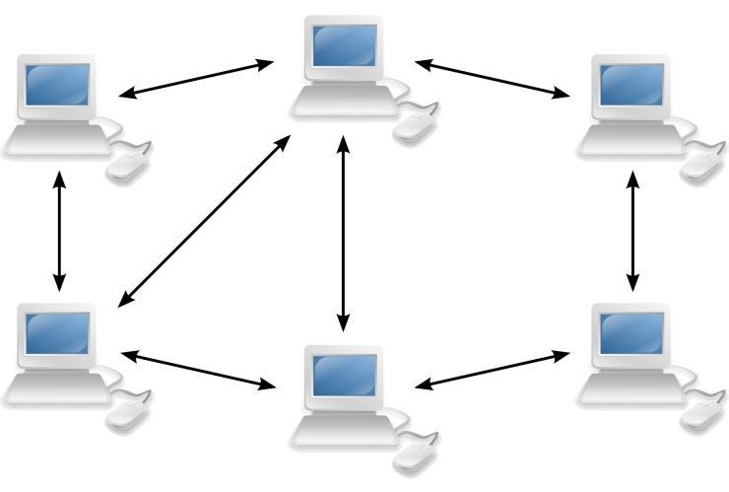

* 1. **Peer to peer.**
  2. Client - server.
  3. Client - client.
  4. Peer to server.

1. **(1 mark)**

The maximum amount of data that can be transmitted over a network during a given time is known as:

* 1. frequency.
  2. broadband.
  3. twisted pair.
  4. **bandwidth.**

1. **(1 mark)**

The code below is a sample of high level language written as:

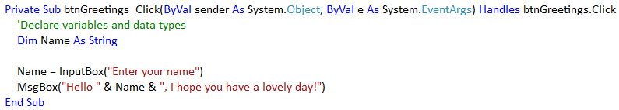

* 1. Executable code.
  2. Machine code.
  3. Pseudo-code.
  4. **Source code.**

**SECTION TWO - SHORT ANSWER 70 MARKS**

*Using protocols*

1. **(4 marks)**Complete the diagram below to show the interaction of components in a communication system.

**Input Device**

**Message** sent over the **transmission medium**

**Output device**

*Using protocols*

1. **(3 marks)**Fill in the term that would be the most appropriate for each description.

|  |  |
| --- | --- |
| **Description** | **Term** |
| A set of computer programs that controls the hardware and acts as an interface with application programs. | **Operating system** |
| Software downloaded at no cost that requires some payment to be registered for continued use. Users are encouraged to pass the unregistered version on to their friends. | **Freeware** |
| A set of rules for exchanging data between two computers. For example: TCP/IP | **Protocols** |

1. **(2 marks)**Describe each of the following communication networks.

|  |  |
| --- | --- |
| Wide Area Network (WAN) | **A network of geographically distant computers** |
| **and terminals. It uses communication services provided by the local phone** | |
| **companies.** | |
| Personal Area Network (PAN) | **A computer network used for communication** |
| **among computerised devices, including telephones and personal digital** | |
| **assistants.** | |

1. **(1 mark)**How does encryption provides security of information over the Internet.

|  |
| --- |
| **Encryption is a process of converting readable data into unreadable characters** |
| **to prevent unauthorized access. It has to be decrypted or deciphered into a readable form.** |

1. **(4 marks)**For each of the following examples of software, indicate whether it is an “application” or “operating system” or “utility”.

|  |  |
| --- | --- |
| **Software example** | **Software Type** |
| *Linux* | *Operating system* |
| Windows 10 | **Operating system** |
| Microsoft Access | **Application** |
| Minecraft | **Application** |
| Norton AntiVirus 2019 | **Utility** |

1. **(3 marks)**Complete the table below by writing in the most appropriate communication protocol for each definition. The first one is done for you.

|  |  |
| --- | --- |
| **Protocol** | **Definition** |
| *HTTPS* | *Protocol developed with secure, safe Internet transactions* |
| **FTP** | A standard for the exchange of program and data files across a network |
| **WAP** | A protocol for accessing information over a mobile wireless network, no matter what type of wireless technology is being used |
| **SMTP** | A data transmission format used to send and receive e-mail |

1. **(2 marks)**Convert the 010110112 into its decimal equivalent. Show all of your working.

|  |
| --- |
| **(0*27) + (1*26) + (0*25) + (1*24) + (1*23) + (0*22) + (1*21) + (1*20)** |
| **= 0 + 64 +0 + 16 + 8 + 0 + 2 + 1** |
| **= 9110** |
|  |

1. **(2 marks)**Convert the 10110112 into its hexadecimal equivalent. Show all of your working.

|  |
| --- |
| **=0101 1011** |
| **= 0 + 4 + 0 + 1 8 + 0 + 2 + 1** |
| **= 5 11 (11 = B)** |
| **= 5B16** |

1. **(3 marks)**Convert the 117 into its binary equivalent. Show all of your working.

|  |
| --- |
| **117 / 2 = 58 r 1** |
| **58 / 2 = 29 r 0** |
| **29 / 2 = 14 r 1** |
| **14 / 2 = 7 r 0** |
| **7 / 2 = 3 r 1** |
| **3 / 2 = 1 r 1** |
| **1 / 2 = 0 r 1** |
|  |
| **11710 = 11101012** |
|  |

1. **(5 marks)**List an example of an activity that would be completed in the following stages of the software development process.

|  |  |
| --- | --- |
| **Stage** | **Activity** |
| State the problem | * **Create an IPO chart** |
| Plan and design | * **Write the algorithm** * **Desk check the algorithm** * **Sketch the form layout** |
| Develop | * **Create the program in the high level language** * **Include project documentation (internal & external)** |
| Test | * **Use the test data from the trace table to ensure that the program runs correctly** * **Debug and modify the program if required** |
| Evaluate | * **Check the program does what it is supposed to do** * **Check if the program is user friendly** * **Check if meaningful identifiers have been used** * **Evaluate if the program needs improvement** |

1. **(3 marks)**Identify the **error type** for each of the situations: The first one has been done for you.

|  |  |
| --- | --- |
| **Situation** | **Error type** |
| *The program will not compile* | *Syntax/compile* |
| Entering 2m instead of 2, which causes the program to stop | **Runtime** |
| Instead of displaying 3 + 10 = 13, the program displays 3 + 10 = 30 | **Logic** |
| Source code is missing a closing bracket in a msgbox statement | **Syntax/compile** |

1. **(3 marks)**Give an example of a variable that could be used to store a value with each data type listed in the table below. The first one has been done for you.

|  |  |
| --- | --- |
| **Data type** | **Example** |
| *Boolean* | *Response* |
| Integer | **Number of seats, children, balls, people** |
| String | **Name, address, subject code, title** |
| Currency | **Price, salary, cost, fees** |

1. **(8 marks)**In the table below, explain the programming terms and give an example of each using the pseudo-code.

Module CalculateTotalPassed

TotalPassed 🡨 0

For Student 🡨 1 to 15

Input(TestScore)

If TestScore > = 50 then

TotalPassed 🡨 TotalPassed + 1

End If

End For

Output(TotalPassed)

End Module

|  |  |
| --- | --- |
| **Initialisation statement** | **The starting value of a variable.** |
|  | |
| *Example:* **TotalPassed 🡨 0** | |
| **Variable** | **Variable is a container used to hold value that can** |
| **change in a program. They must have meaningful names.** | |
| *Example*: **TotalPassed, Student, TestScore** | |
| **Control structure** | **Repetition - A statement or group of statements can happen a number of times** |
| **Selection - A decision is made based on a condition eg. TestScore > = 50?**  **Only one of the possible paths can be followed.** | |
| *Example*: **For, End For / If, End IF** | |
| **Output statement** | **A statement that display the output to the user** |
|  | |
| *Example*: **Output(TotalPassed)** | |

1. **(5 marks)**Desk check the following algorithm using the test data: 6, no; 9, no; 18, no; 45, yes.

Module CalculateTotalSales

TotalSalesValue 🡨 0

Repeat

Input (SaleValue)

TotalSalesValue 🡨 + SaleValue

Output(“Have you finished entering sales yet?”)

Input (Response)

Until Response = “yes”

Output (TotalSalesValue)

End Module

|  |  |  |  |  |
| --- | --- | --- | --- | --- |
| **SaleValue** | **TotalSalesValue** | **Response** | **Response=’yes”?** | **Output** |
|  | **0** |  |  |  |
| **6** | **0 + 6 = 6** | **no** | **False** |  |
| **9** | **6 + 9 = 15** | **no** | **False** |  |
| **18** | **18 + 15 = 33** | **no** | **False** |  |
| **45** | **45 + 33 = 78** | **yes** | **True** | **78** |

1. **(4 marks)**Name 4 high-level programming languages.

|  |
| --- |
|  |
|  |
| **Java, C++, Scratch, Pascal, Python, Swift, COBOL, PHP, Visual Basic Express** |
|  |

1. **(2 marks)**What is the difference between a low-level programming language and a high-level programming language?

|  |
| --- |
| **A low-level language program is more difficult to write than high-level language code.**  **Low level language code is closer to the language used by the computer’s CPU and high-level language code is closer to human language.** |
|  |
|  |
|  |

1. **(2 marks)**Define secondary storage and give an example.

|  |
| --- |
| **Secondary storage provides permanent storage of programs and data when the computer is turned off.** |
|  |

1. **(4 marks)**Complete the following table to describe the characteristics of different transmission media.

|  |  |
| --- | --- |
| **Media name** | **Description** |
| Satellite | **It provides high-speed internet connections via satellite to a satellite dish that communicates with a satellite modem.** |
| **Twisted pair** | A type of cable that consists of two independently insulated wires twisted around one another. The use of two wires twisted together helps to reduce *noise* |
| Fibre optic | **Dozens or hundreds of thin strands of glass or plastic tubes that use light to transmit signals.** |
| **Cellular** | A broadcast radio form that is used widely for mobile phone communications. |

1. **(6 marks)**Identify 6 errors in the following Data Flow Diagram.

*Level 0 Data Flow Diagram*

Customer Order Form

details

1.0

Process order form

Customer

Stock List

Adjusted Item Quantity

Processed Customer Order Form

Invoice detail

Invoice item

Pending Invoices File

Processed Customer Order Form

Copy of Invoice

Supplier

3.0

Order Item

Stock Order Form

Item Quantities

|  |
| --- |
| Error 1: **Process 2 does not have number 2.0 on it.** |
| Error 2: **Process 3 does not have data flow going out of it, only going in.** |
| Error 3: **Stock List data store has the wrong shape convention. Should be one line above and below of it.** |
| Error 4: **Data flow coming out from Stock List data store to process 1.0 does not have a name.** |
| Error 5: **Customer entity has the wrong shape, should be rectangle.** |
| Error 6: **Data cannot flow directly from one data store to another. It must go through a process.** |

1. **(4 marks)**List down the steps to complete a project in project management..

|  |  |
| --- | --- |
| i. | **Plan** |
| ii. | **Budget** |
| iii. | **Schedule** |
| iv. | **Track** |

**SECTION THREE - EXTENDED ANSWER 70 MARKS**

1. **(15 marks)**Morley Accountant is a small accounting business located in Morley Galleria. It currently has the following network layout.

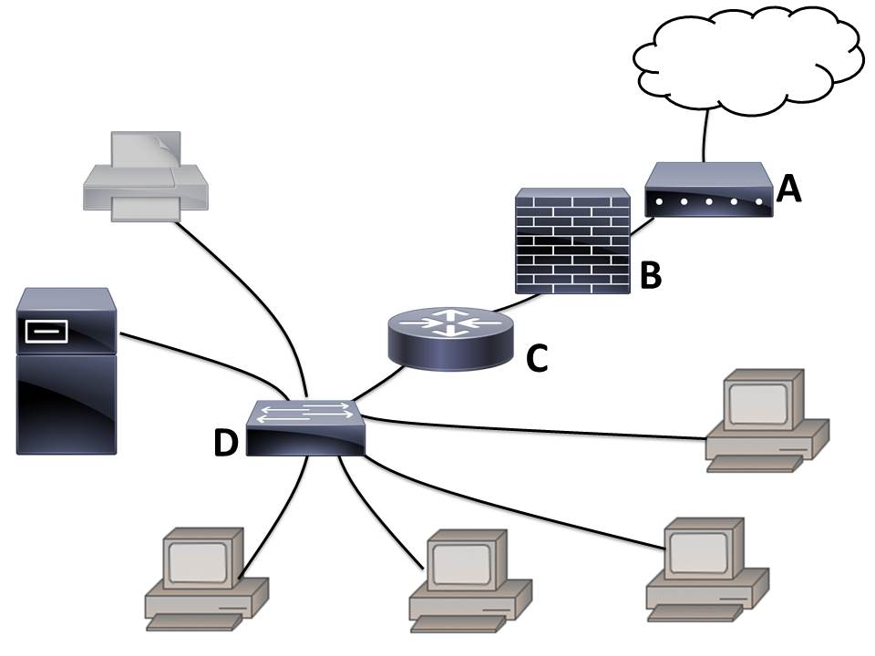

1. (3 marks)  
   Complete the table below by entering the names of each of the labelled devices shown in the network diagram. The first one has been done for you.

|  |  |
| --- | --- |
| **Label** | **Device Name** |
| ***A*** | *Modem* |
| **B** | **Firewall** |
| **C** | **Router** |
| **D** | **Switch** |

1. (3 marks)  
   State the function of each of these devices. The first one has been done for you.

|  |  |
| --- | --- |
| **Label** | **Function** |
| ***A*** | *Converts a computer’s digital signal into an analogue signal needed for transmission over the standard telephone line (and vice versa).* |
| **B** | **Hardware and/or software that protects a network’s resources from intrusion by users on another network such as the internet.** |
| **C** | **Directs communications traffic and determines the best path for data to travel when several networks are connected together.** |
| **D** | **Provides a central connection point for a number of computers and. It uses MAC addresses to filter and forwards data packets.** |

1. (1 mark)  
   Currently the business uses a wired network. Describe **one advantage** of using unshielded twisted pair (UTP) rather than a wireless medium.

|  |
| --- |
| **Cheap, flexible, easy to install, reliable** |
|  |

1. (1 mark)  
   Describe **one disadvantage** of using unshielded twisted pair (UTP) rather than a wireless medium.

|  |
| --- |
| **Leaving the wiring if there’s a change of topology.** |
| **Expensive to make changes to wiring.** |
| **Slower bandwidth as compared to other transmission medium.** |

1. (1 mark)  
   The business wants to replace 2 desktop computers with 2 wireless laptops. What extra device will need to be purchased so that the laptops can connect to the file server and printer?

|  |
| --- |
| **A wireless access point (WAP) to allow the 2 laptops to send and receive data from the file server and printer without the need for cables.** |

1. (6 marks)  
   Redraw the network diagram to show the new **layout of the altered section of the network** based on Question 41e above.

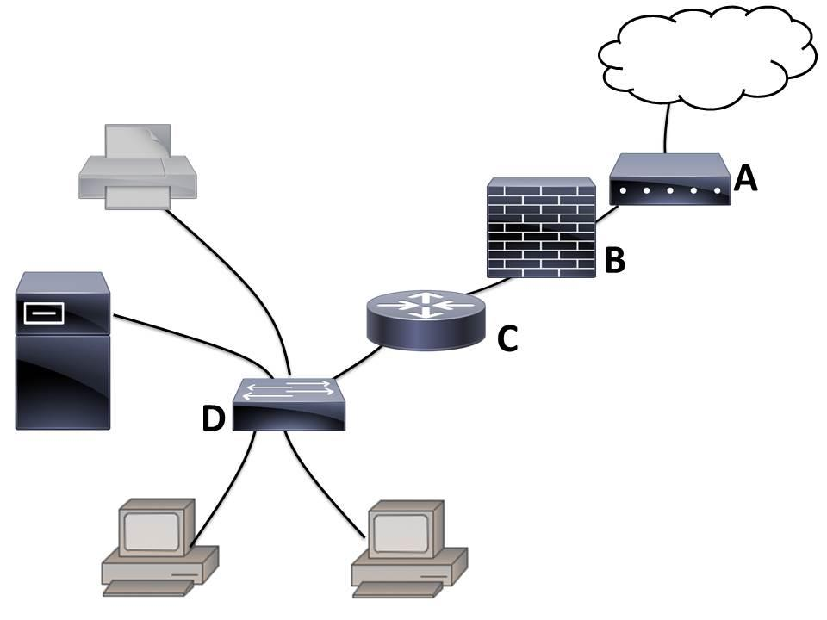

**1 WAP - 1m**

**2 Laptop – 2m**

**2 wireless connections – 1m**

**1 UTP from switch to WAP – 1m**

**Correct drawing of other components based on the original diagram – 1m**

1. **(20 marks)**Morley Accountant needs to guard itself from the malicious software. It has two methods of data protection applied to its business. Answer the following questions:
   1. (2 marks)  
      Describe two ways that the company could use to prevent their computer from being infected by a virus.

**Any 2 ways:**

* **Install the latest anti-virus software that can detect any malware on your computer and remove them.**
* **Download files only from trusted sites**
* **Don't open unknown attachments or links from sites or emails that are not trustworthy**
* **Perform daily scans**
  1. (4 marks)  
     Describe each of the following malware:

|  |  |
| --- | --- |
| **Virus** | **a potentially damaging computer program that affects, or** |
| **infects, a computer negatively by altering the way the computer works without the user’s knowledge or permission.** | |
| **Worm** | **program that copies itself repeatedly, using up system** |
| **resources and possibly shutting down the system.** | |
| **Trojan** | **program that hides within or looks like a legitimate program.** |
|  | |
| **Spyware** | **program placed on a computer without the user’s knowledge** |
| **that secretly collects information about the user.** | |

* 1. (1 mark)  
     What is data protection?

**Data protection is the process of safeguarding important data from** [**corruption**](http://searchsqlserver.techtarget.com/definition/data-corruption)**, loss or misuse.**

* 1. (4 marks)  
     Name and describe the two main methods of data protection?

Method 1: **ENCRYPTION**

**Encryption is the process of converting readable data (called plain text) into unreadable characters (called cipher text), so as to prevent unauthorised access. An encryption algorithm (cypher) is used to convert the readable plain text into unreadable cipher text.**

Method 2: **AUTHENTICATION**

**Authentication is a process in which the identifications provided are compared to those on file in a database of authorized users' information on a local operating system or within an authentication server. If the credentials match, the process is completed and the user is granted authorisation for access.**

* 1. (5 marks)  
     Complete the ERD to show a manager in Morley Accountant manages many staff members but the staff member only has one manager. You will need to add:
* The relationship and cardinality **1m**
* Add a primary key to Staff Member entity **1m**
* Two more attributes for the Staff Member entity **1m**
* Underline the primary keys **1m**
* Add the foreign key **1m**

**manages**

**1**

**M**

Manager

Staff Member

* 1. (4 marks)  
     Below is a screen capture of Morley Accountant software.

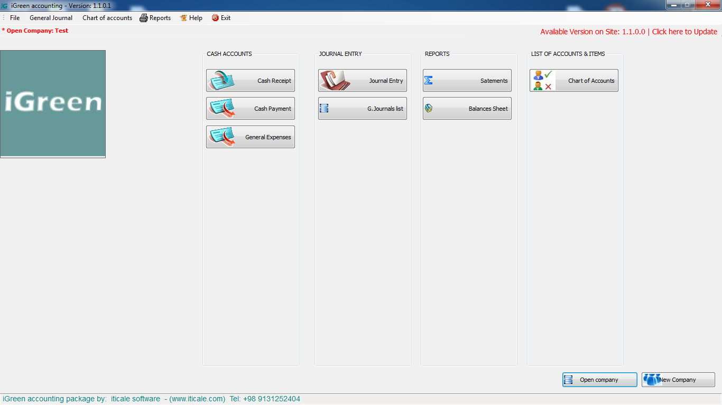

Morley Accountant

**CLOSE**

* + 1. Describe 2 features you like about the user interface design. (2 marks)

|  |  |
| --- | --- |
| **Feature 1:** | **Any appropriate answers:** |
| **Eg. Clear shape on each button, readable font size for CLOSE button, contrast colour for between word and background for CLOSE button and company’s name** | |
| **Feature 2:** |  |
|  | |

* + 1. Describe 2 features that **should be improved** with the user interface design. (2 marks)

|  |  |
| --- | --- |
| **Feature 1:** | **Any appropriate answers:** |
| **Eg. No label on the last button, font size too small for Rectangle, inappropriate script font for company’s name and not within one line the word “Accountant”** | |
| **Feature 2:** | **Form title and instructions are non-readable (both text and** |
| **background colours are dark)** | |

1. **(6 marks)**Look at the following database that has 2 tables in it. Both tables have its own primary key. However, tblPlayer has a foreign key as well called ClubIDFK. Answer the following questions based on the database below.

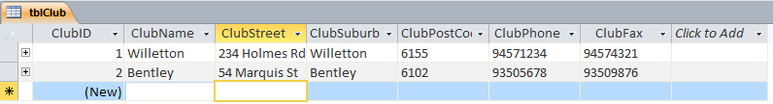

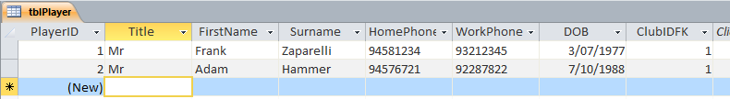

* 1. (1 mark)  
     Can you edit the number for PlayerID?

**No, it cannot be edited as the data type is AutoNumber.**

* 1. (1 mark)  
     What happens to the data type AutoNumber when a record is deleted?

**Once a record is deleted with the data type AutoNumber, the number will be lost forever as it cannot be added again. The next following number will appear instead even if the rest of data is the same.**

* 1. (2 marks)  
     Explain why AutoNumber an efficient data type for entering ID numbers/primary keys?

**It is efficient if you want a quick way of getting a unique number, but it is not useful if you make a mistake and delete a record as you cannot use that number again.**

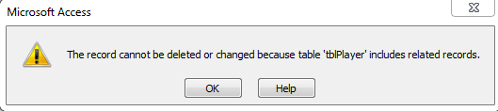

* 1. (2 marks)  
     Explain why you cannot delete the Bentley club from tblClub.

**Bentley club has 2 players in it; ClubID2 (Bentley club) is linked to the Player table. If we deleted Bentley club from the Club’s table, we would have inaccurate data – as we have 2 players for a club which no longer is listed in our database**

1. **(4 marks)**Write an algorithm that will ask the user to enter the number of chocolates required then calculate and display the total cost of the chocolates. A chocolate costs $3.75.

|  |  |
| --- | --- |
| **Module CalcChocCost** | |
| **Price = 3.75** | **1** |
|  |  |
| **Output(“Enter the number of chocolates required.”)** | **½** |
| **Input(NumChocs)** | **½** |
| **TotalCost 🡨 NumChocs * Price** | **1** |
| **Output(“Total cost is $”, TotalCost)** | **1** |
| **End Module** |  |

1. **(5 marks)**Write an algorithm which will accept a height in centimetres and outputs that height in terms of metres and centimetres.  
   For example: 237 cm = 2 m and 37 cm.

|  |  |
| --- | --- |
| **Module ConvertHeight** | |
| **Input (Height)** | **1** |
|  |  |
| **NumMetres 🡨 Height DIV 100** | **1** |
| **NumCm 🡨 Height MOD 100** | **1** |
|  |  |
| **Output( Height, “ cm = ”, NumMetres, “m and “, NumCm, “ cm.”)** | **2** |
| **End Module** |  |

1. **(8 marks)**Write an algorithm that calculates the average score that basketball players achieved in a game. The algorithm should

* accept the number of players in the team
* accept the score for each player
* calculate the total score for the team
* calculate the average score for the team
* display the total and average scores.

|  |  |
| --- | --- |
| Module BasketballStats | |
| **Total 🡨 0** | **1** |
| **Input (NumPlayers)** | **1** |
| **For Player 🡨 1 to NumPlayers** | **1** |
| **Input (Score)** | **1** |
| **Total 🡨 Total + Score** | **1** |
| **End For** |  |
| **Average 🡨 Total / NumPlayers** | **1** |
| **Output (“Total score is “ , Total, “ and average player score is “, Average)** | **2** |
| **End Module** | |
|  | |

1. **(4 marks)**Write an algorithm in pseudo-code asking the user to enter the number of days that they will be on holidays. Calculate the number of weeks and days and display a message showing the number of weeks and days. (4 marks)

Example: 23 days would be 3 weeks and 2 days

Hint: Use MOD and DIV

**Output(“Enter the number of days.”) ½**

**Input(TotalDays) ½**

**Weeks 🡨 TotalDays DIV 7 1**

**Days 🡨 TotalDays MOD 7 1**

**Output(TotalDays, “days would be ”, Weeks , “ weeks and ” , Days, “ days.”) 1**

1. **(8 marks)**Convert the following pseudo-code to a flowchart on the next page. The first line has been done for you.

Module CalculateChocolateCost

Input (BoxCost)

Input (NumChocsInBox)

Input (NumStudents)

If NumStudents MOD NumChocsInBox = 0 then

NumPacks 🡨 NumStudents DIV NumChocsInBox

Else

NumPacks 🡨 (NumStudents DIV NumChocsInBox) + 1

End If

TotalCost 🡨 Numpacks * BoxCost

Output (TotalCost)

End Module

Flowchart:

Start

**Input BoxCost**

**Input NumChocsInBox**

**Input NumStudents**

**NumStudents MOD NumChocsInBox = 0?**

**End**

**Output TotalCost**

**TotalCost 🡨 Numpacks * BoxCost**

**NumPacks 🡨 NumStudents DIV NumChocsInBox**

**NumPacks 🡨 (NumStudents DIV NumChocsInBox) + 1**

Yes

No